Creel Data QAQC Report, v2

Freshwater Recreational Fisheries Management Unit

Washington Department of Fish and Wildlife

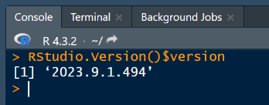*Disclaimer: The QAQC script is a Quarto document, a more advanced alternative to R Markdown. You must have RStudio version 2022.07 or newer to run this code. You can check your computer’s RStudio version by running the following code in your RStudio Console:* RStudio.Version()$version *If your software is older than 2022.07, please work with IT to get a newer version installed.*

**Tip:** If your report fails on the very first attempt, update the `gt` package by running install.packages(“gt”)in your R console. You need at least version 0.10.0.

**Instructions**

1. Save a copy of the file “[creel_qaqc_report_v2.1.qmd](https://stateofwa.sharepoint.com/:u:/r/sites/DFW-TeamFPFWCreelMonitoringProgram163/Shared%20Documents/General/Project_Support_Files/Data%20Quality%20Assurance/creel_qaqc_report_v2.1.qmd?csf=1&web=1&e=mjK9yV)” to your local computer. This file is located in the Freshwater Recreational Fisheries Management (FRFM) unit’s Team at:
   * DFW-Team FP FW Creel Monitoring Program - General\Project_Support_Files\Data Quality Assurance\
2. Open the Quarto (.qmd) file in RStudio.
   * This version of the file is self-contained, meaning it does not rely on external folders or files. In the future, this will likely be integrated into the [CreelEstimates GitHub repository](https://github.com/wdfw-fp/CreelEstimates) and would need to be run from within the CreelEstimates R Project.
3. 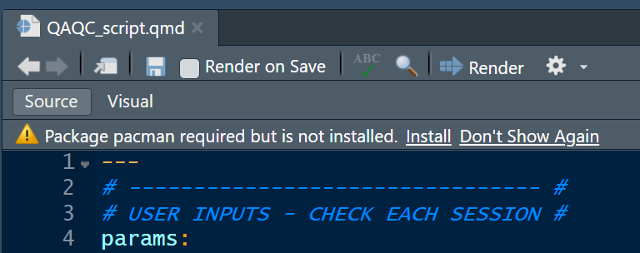Install any missing R packages automatically prompted by RStudio.
   * If this option does not prompt for you, make sure that the R package pacman is installed by running install.packages(“pacman”) in your console. This package must be installed because on line 58 of the script the function p_load() attempts to install the necessary packages and their dependencies for you.

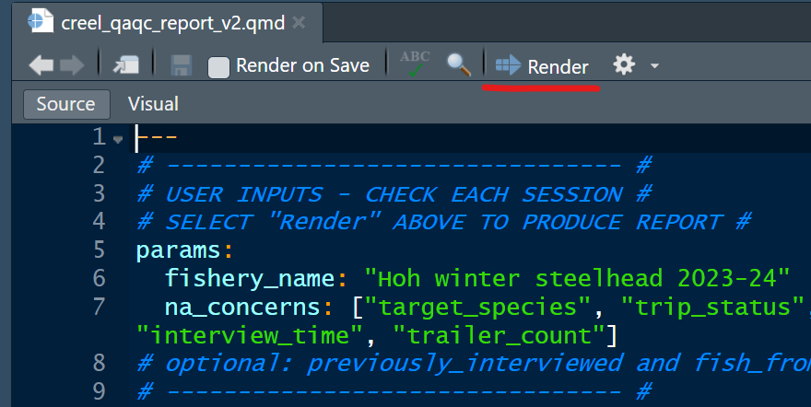

1. Provide user inputs to parameters. Change the “fishery_name” value to match a fishery of interest in the creel database. A list of available fishery names can be found through the [Fishery Manger](https://data.wa.gov/dataset/WDFW-Creel-Fishery-Manager/vkjc-s5u8/about_data) view on data.wa.gov.
   * These fisheries must have been established via the “fishery lookup table” in the Fishery Manager tab on FishApps and have a fishery_name variable applied to the data on data.wa.gov. Establishing new fisheries in or making edits to the lookup table is outside the scope of these instructions but if you need assistance with this, please contact Colt Holley ([colt.holley@dfw.wa.gov](mailto:colt.holley@dfw.wa.gov)).
2. Select “Render” as shown in the picture in step 4.
   * The script will begin to run, and hopefully, will produce a HTML output document. This may take several minutes the first time. It may either open within the RStudio “Viewer” pane or as a new tab within your default internet browser.

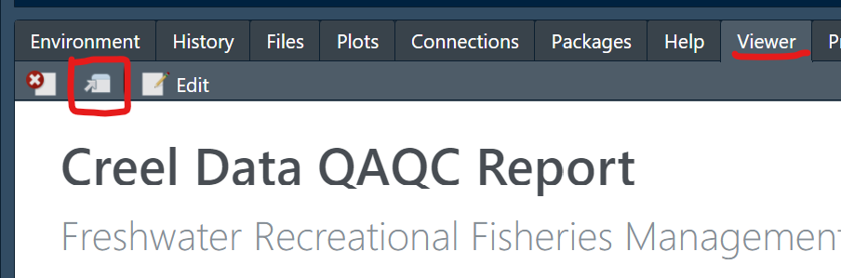

* + 1. If the report opens within the Rstudio “Viewer” pane, select the icon show in the red square above to open in a browser.
  + If you encounter errors, please contact Colt Holley for assistance. Most likely pacman did not successfully install all the necessary package dependencies on the first attempt. If your Console reports errors to the effect of “could not find function XYZ” or “there is no package called XYZ”, you may need to manually install dependent packages that failed to download automatically.
  + Optionally, you may run each R code chunk in the Quarto document manually to isolate the error.